**RIPHAH INTERNATIONAL UNIVERSITY, ISLAMABAD**



**Lab 12**

**Bachelors of Computer science – 5th semester**

**Subject:** Operating System Lab

**Submitted to:** Ma’am Kausar Nasreen Khattak

**Submitted by:Faareha Raza**

**Sap Id:** 47431

**Lab Tasks:**

**Q1:** Which command would you use to find the process ID (PID) of a process named OSLab without running it. After obtaining the PID, which command would you use to kill the process?

**Answer:**

**Command:** To find the process ID (PID) of a process named OSLab, we use: **pidof OSLab**

This command returns the PID of process with the name OSLab.

After obtaining the PID, we can terminate the process with the kill command:

**Command: kill <PID>**

If we need to forcefully terminate the process, we can add the -9 option: **kill -9 <PID>**

**Q2:** How would you write a script that uses a signal trap to handle specific signals, and what is the purpose of a signal trap in such a script?

**Answer:**

**Code:**

#!/bin/bash

# Define a function to handle signals

handle_signal() {

echo "Signal caught, performing cleanup..."

# Add any cleanup or exit steps here

exit 0

}

# Set up a trap to catch SIGINT (Ctrl+C) and SIGTERM

trap handle_signal SIGINT SIGTERM

# Main script loop

while true; do

echo "Running... Press Ctrl+C to stop."

sleep 1

done



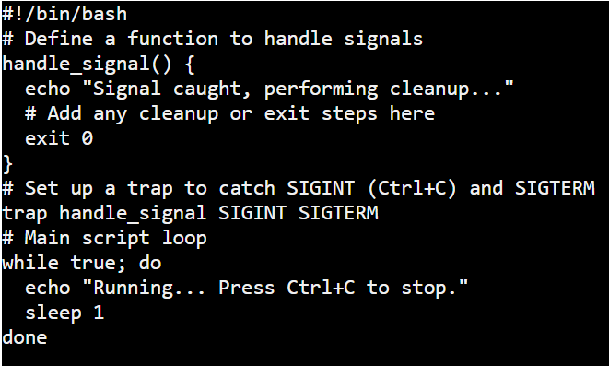

Esc

Shift+:

wq

Enter

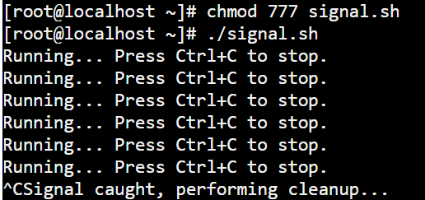

**Function Definition**: handle_signal is defined to execute any cleanup tasks, and it prints a message before exiting the script with a status of 0 (indicating a normal exit).

**Setting Up the Trap**: trap handle_signal SIGINT SIGTERM tells the script to call the handle_signal function when it receives either a SIGINT (interrupt, often triggered by pressing Ctrl+C) or SIGTERM (termination signal).

**Infinite Loop**: The script runs an infinite loop, printing "Running... Press Ctrl+C to stop." every second until interrupted.

**Purpose:**

A signal trap allows a script to handle interruptions gracefully by executing specific commands when a signal is received. A signal trap allows a script to intercept signals like SIGINT (interrupt, typically from pressing Ctrl+C), SIGTERM (terminate), and others. This lets the script perform cleanup tasks, such as saving data, closing files, or releasing resources, before exiting gracefully.